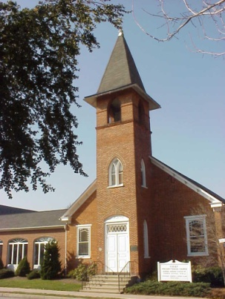

First Presbyterian Church

Strasburg, PA

Application for Employment

101 South Decatur Street
Strasburg, PA 17579
(717) 687-6030
straspres@straspres.org
www.straspres.org

June 24, 2014

Please print all responses

Personal Data

Last Name : First Name:

Middle Name: Preferred Name:

Previous Names/Aliases:

Street Address:

City: State: Zip:

Daytime Phone: ( ) Evening Phone: ( )

Cell Phone: ( ) E-mail Address:

Best time to contact by phone: Social Security Number:

- Are you legally eligible for employment in the United States?

- Have you ever been convicted of a felony?

If “Yes”, please explain in the space provided on page 4.

Your Education Background

School/College Name Years Degree/Special Honors
Completed

High
School:
Technical
School:
College:

Professional Studies/Extracurricular Activities/Other:

Employment History
Please list your immediate past three employers and requested information about each.

1. Name of Company/Employer:
(Your last or current employer)

Job Title: Name of Supervisor:

Beginning Date of Employment: Final Date of Employment:

Address:
Phone Number: ( )

May we contact them

Reason you left/are leaving

2. Name of Company/Employer:

Job Title: Name of Supervisor:

Beginning Date of Employment: Final Date of Employment:

Address:

Phone Number: ( )

May we contact them

Reason you left/are leaving:

3. Name of Company/Employer:

Job Title: Name of Supervisor

Beginning Date of Employment: Final Date of Employment:

Address:

Phone Number: ( )

May we contact them

Reason you left/are leaving:

Your Spiritual Journey

Please tell about your personal faith journey with Jesus Christ (attach additional sheets as necessary):

Additional Information:

(attach additional sheets as necessary)

Signature and Understanding

By signing this Employment Application: I represent that all of the information included is true to the best of my knowledge and understand that any attempt on my part to provide false information will exclude me from being considered for a position or would result in subsequent dismissal should I be hired. I understand that this information in no way creates an agreement of employment. I understand that a full criminal background check will be performed and be further used in determining my suitability for employment. I understand that I must complete the “Reference and Release” form and include it with this application in order to be considered for employment.

___________________________________________ __________________________
(signature) (date)

First Presbyterian Church is committed to equal employment opportunity for all qualified persons. This applies to all employment practices, including hiring, promotions, training, disciplinary action, termination, and benefits. All employees

are expected to show respect and sensitivity toward all other employees and to demonstrate a commitment to the Church’s equal opportunity objectives.

References and Release Form

Please name one employer (listed on this Employment Application) which we may contact to serve as references:

Company Name:

Contact Person: Phone: ( )

E-mail Address: Cell Phone: ( )

Relationship of Contact Person to you:

Please list two personal references (other than family members) who will testify to your ability to serve in ministry and your personal faith in Jesus Christ:

1. Person’s Name:

Phone: ( ) E-mail Address:

Relationship of Person to you:

2. Person’s Name:

Phone: ( ) E-mail Address:

Relationship of Person to you:

Release

By signing below, I hereby give the First Presbyterian Church of Strasburg, PA permission to contact all references listed on this page (or attached to my resume). I agree and hold harmless all individuals named. I understand that their conversations with First Presbyterian Church will be for the express purpose of making an employment decision, either favorable or unfavorable.

___________________________________________ __________________________
(signature) (date)

